 **Journal of Researches in Agricultural Sciences**

**©2018 Copyright Faculty of Agricultural Sciences Journal,**

**Ekiti State University, Ado-Ekiti. Nigeria**

<http://faculty.eksu.edu.ng/agric.office/published-volumes> Vol. 6 (2), September 2018. Pp 20-28

**Medicinal Uses of Ackee-apple (*Blighia sapida* K.D Koenig) in Rainforest and Savanna Areas of South Western Nigeria**

**\*A. E. Awoku, S. A. Adeduntan, and V.O. Oyerinde**.

*Department of Forestry and Wood Technology,*

*The Federal University of Technology, P.M.B 704 Akure, Nigeria*.

*E-mail: [awokuadeola@gmail.com](mailto:awokuadeola@gmail.com)

**Abstract**

Fruits from the forests have multiple benefits for mankind in the areas of food, spices for cooking, medicine and income generation. The study was conducted in 10% of the total number of local government area randomly selected in the rain forest and savannah vegetation zone in South-west Nigeria. Information on the dependence of *Blighia sapida* for medicinal use was collected from eight (8) respondents in three communities of each selected local government using a semi-structured questionnaire and descriptive statistics used to analyze the data. The respondents predominantly use various parts of the tree to cure malaria. The variation observed among respondents in the states and vegetation zones suggests that people should be enlightened more on the effective uses of the plant to cure various ailments. More awareness needs to be created on the existence of *Blighia sapida* as it is not widely known like other fruits trees such as bitter cola (*Garcinia kola)* and white star apple (*Chrysophylum albidum)*. Efforts should be made towards the domestication of *Blighia sapida* because of the threat into extinction caused by harvesting the timber for its high density wood.

**Keywords**: *Blighia sapida,* Medicinal, vegetation zone, Indigenous knowledge, South-west.

**Introduction**

Since prehistoric times, humans have used natural products, such as plants, animals, microorganisms, and marine organisms in medicines to alleviate and treat diseases. According to fossil records, the human use of plants as medicines may be traced back at least 60,000 years (Shi, *et al.,* 2010, Fabricant, and Farnsworth, 2001). The use of natural products as medicines must, of course, have presented a tremendous challenge to early humans. It is highly probable that when seeking food, the early humans often consumed poisonous plants,  
which led to vomiting, diarrhoea, coma, or other toxic reactions—perhaps even death. However, in this way, early humans were able to develop knowledge about edible materials and natural medicines (Gao, 2007). Subsequently, humans invented fire, learned how to make alcohol, developed religions, made technological breakthroughs, and learned how to develop new drugs.

The health crisis has been an issue to mankind, and through research, herbal medicine has proven to be effective in providing solution to diverse sicknesses and diseases. The fruits from the forest have multiple benefits for mankind in the areas of food, medicine, income and as spices for cooking. Research on several forest fruits has revealed their medicinal properties, importance and benefits and how they can be useful in treating different ailments. The knowledge has been built for decades on the use of herbal medicinal products and extracts in the treatment of human diseases (Iwalewa *et al*., 2007). The parts of a tree that can be useful for traditional medicine includes the fresh or dried fruits, whole, chopped, powdered or an advanced form of the herb usually made via extraction by a solvent such as water, ethanol or an organic solvent which play a major role and constitute the backbone of traditional medicine (Mukherjee, 2002). Various pharmacological examinations such as antibacterial, antiviral and antioxidant activities have been carried out which increased the quest for the investigation and evaluation of plants that were once considered of no value to be and developed into drugs with little or no side effects on the organisms (Adedeji *et al.,*2006). An example of such plant is Ackee apple (*Blighia sapida).* The premonition of Ackee apple has been recognized in the healing of several diseases. These include dental decay, fever, malaria, internal haemorrhage, dysentery, burns, eyes inflammation, yellow fever, constipation, cutaneous infections, whitlow and head lice (Barceloux, 2009). The sap from the terminal buds is instilled in the eyes to treat ophthalmia and conjunctivitis. The bark and leaf decoctions are administered to treat oedema, intercostal pain, dysentery and diarrhoea. Irvin (1961) noted that in Ghana, the bark is ground-up with pepper (*Capsicum annuum* L.) and rubbed on the body as stimulant while the pulp of ground leafy twigs is rubbed on the forehead to treat migraine. In Côte d’Ivoire and Nigeria, the ground leaves are applied as a paste together with plant salts to treat yaws and ulcers (Prota 7(2017).

In traditional medicine in Côte d’Ivoire, Ackee apple is widely used for the treatment of yellow fever, epilepsy and oedema and as a laxative and diuretic. The seeds are taken in Ghana to control nausea and vomiting. In Benin, the leaves are used in the treatment of fever and vertigo, and twigs to treat hepatitis, cirrhosis and amygdalitis. In Togo, decoctions of bark or fruit walls are applied to wounds, and the fruit pulp to treat whitlow. Pounded bark is administered as an antidote to snake and scorpion bites, and pounded seeds to treat stomach complaints. This type of knowledge is kept mostly by old people and traditional healers in the communities and varied sometimes from one ethnic group to the other (Prota 7(2017)

**Materials and Methods**

The study was conducted in south-west Nigeria. A multistage sampling technique was used. Ondo, Oyo and Osun states where randomly selected from the six states in the southwest, Nigeria. Ondo State had 18 Local Government Areas out of which 4 are in the savanna and 10 in the rainforest; Oyo State contains 33 LGAs with 24 of these in the savanna and 9 in the rainforest while Osun State consists 30 LGAs with 18 in the savanna and 12 in the rainforest. For this study, ten percent of the LGAs in each vegetation zone were randomly selected in each state in the vegetation zones where the ten percent of the local government was not up to one (1), one local government was selected. An interview schedule was carried out to gather information on the medicinal uses of Ackee from eight (8) respondents in three (3) randomly selected communities from the list of the identified communities in each LGAs (Table 1 and Figure 1, 2 and 3).

Table 1: Distribution of LGAs and communities across the states and vegetation zones.

|  |  |  |  |
| --- | --- | --- | --- |
| State | Vegetation Zone | LGAs | Communities selected |
| Ondo | Rainforest | Akure South | Awule, Ijomu, Araromi |
| Savanna | Akoko South-west | Akungba - Akoko, Ayegunle -Akoko, Oba-Akoko |
| Osun | Rainforest | Ife South | Akeredolu, Olode, Ifetedo |
| Ife East | Omi-toto, Ifesowapo, Ifedapo |
| Savanna | Odo-Otin | Okua, Inisha, Okuku |
| Ifelodun | Ikirun, Obaagun, Eko-ende |
| Oyo | Rainforest | Oluyole | Alata, Aba-nla, Idi-ayunre |
| Savanna | Saki East | Ogbooro, Ago-amodu, Oje-owode |
| Saki West | Saki, Idi-Ero, Palapala |

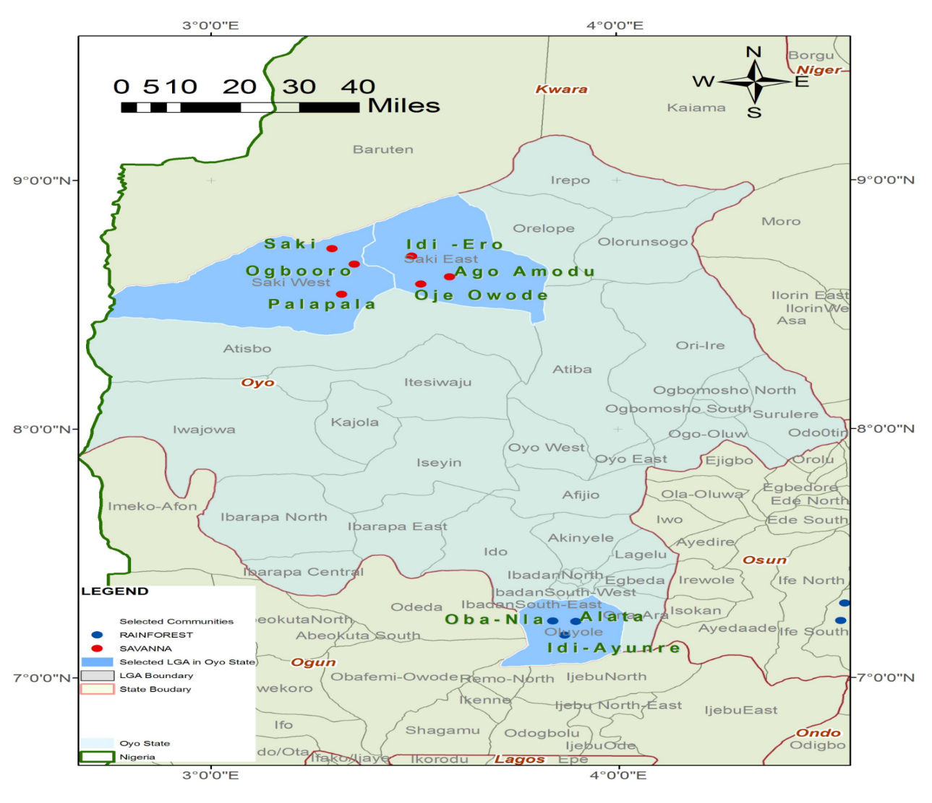

Figure 1: Map of Oyo State Indicating the selected LGAs and communities

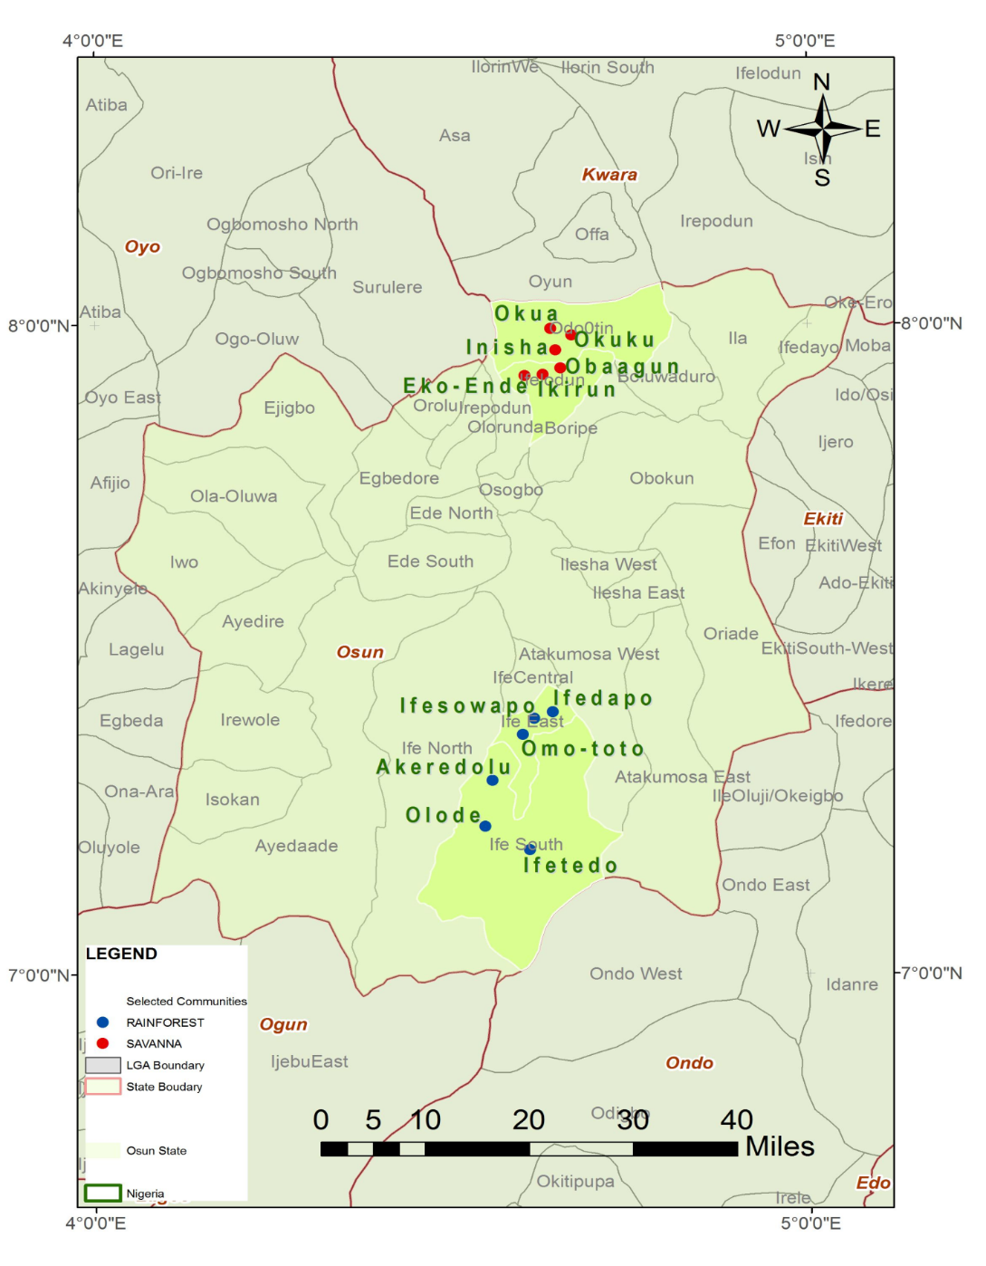

Figure 2: Map of Osun State Indicating the selected LGAs and communities

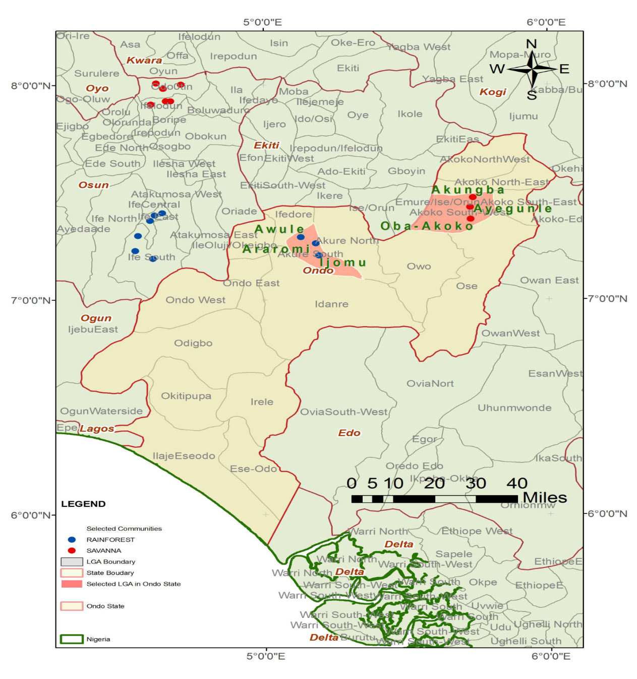

Figure 3: Map of Ondo State indicating the selected LGAs and communities

**Data Analyses**

Information obtained from respondents who answered questions presented in the questionnaire was coded using SPSS 15.0 and analysed with Descriptive statistics.

**Results**

*Medicinal Uses of Ackee*

The result presented in Fig. 4 and 5 indicate that the use of *B. sapida* for curing malaria is prevalent across the study area. In the zone, 25% of respondents in Oyo, 14.6% of respondents in Osun and 16.7% of respondents in Ondo were using the leaves and bark of the plant to cure malaria while 8.3% respondents in Osun and 12.5% respondents in Ondo used the leaves and bark for curing malaria in rainforest areas. The results, respondents in the savanna zones of the three states used ackee plant to cure various prevailing ailments while some of the respondents in the rainforest zones knew little or nothing about the medicinal properties of *B. sapida*. The medicinal and method of use of *B. sapida* across the study area is further presented in Table 2

.

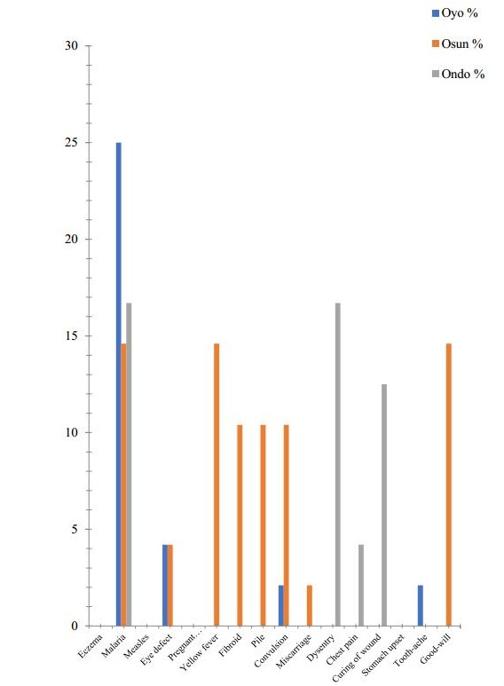

Percentage

**Figure 4: Medicinal Uses of Ackee in Savanna Zones**

*Source: Field Survey 2014*

**Figure 5: Medicinal Uses of Ackee in Rainforest Zones**

*Source: Field Survey 2014*

|  |  |  |  |
| --- | --- | --- | --- |
| Table 2: Medicinal properties of *Blighia sapida* in the study areas | | | |
| State | Vegetation Zones | Diseases | Composition/preparation |
| Ondo | Rainforest | Malaria | Decoction of bark+ leaves |
|  | Savanna | Malaria | Decoction of bark+ leaves |
|  |  | Dysentery | Decoction of leaves + Shea butter |
|  |  | Chest pain | Unripe fruit pounded and rubbed on the chest |
|  |  | Curing of mouth wound | Pound bark part of the tree and cook soup with it. |
| Osun | Rainforest | Eczema | Inner part of seed grinded + palm kernel oil |
|  |  | Malaria | Decoction of bark+ leaves |
|  |  | Measles | Soap made from the pod for bathing |
|  |  | Eye defect | Eating of Aril |
|  |  | Pregnant women/child fever | Infusion of the root |
|  |  |  | Decoction of bark+ leaves |
|  | Savanna | Malaria | Decoction of bark+ leaves |
|  |  | Eye defect | Eating of Aril |
|  |  | Yellow fever | Decoction of seed + leaves + bark |
|  |  | Fibroid | Decoction of seed + leaves + bark |
|  |  | Pile | Decoction of seed |
|  |  | Convulsion | Decoction of seed + leaves + bark |
|  |  | Miscarriage | Decoction of tree bark |
| Oyo | Rainforest | Stomach upset | Inner part of seed grinded + water |
|  | Savanna | Malaria | Decoction of bark+ leaves |
|  |  | Measles | Soap made from the pod for bathing |
|  |  | Convulsion | Decoction of seed + leaves + bark |

Source: *Field Survey2014*

**Discussion**

Some of the medicinal values attributed to ackee in the study areas are well known in other countries where the species occurs as well. The leaves and bark are combined and used to treat sore stomach and yellow fever in Columbia (Abbiw, 1989. The predominant ailment people cure with ackee tree is malaria while few of the respondents knows about the other ailment which can be cured by decoction of the different parts of ackee tree.

Almost all the different parts of ackee are used by the respondents in the study area but the prevalent part used is the aril since most people have little or no knowledge about the diverse uses of the fruit in the areas. Although most people use the aril of ackee only few know how efficient the fruit is when used. The Vitamin content justifies consumption of ackee aril which has the potential of curing eye defect Olawale *et.al* (2016). The phenolic properties of the stem, leaves and bark are higher than the phenol present in the aril (Sofidiya *et. al*., (2012). The total polyphenol present in the stem, leaves and bark however functions as free radical terminator and efficient in preventing auto-oxidation. This explains why the leaves and back of ackee are used to cure various diseases.

**Conclusion and Recommendation**

Ackee has a lot of medicinal values that can be of benefit to man. The leaf, seed and bark of the tree used to cure various kinds of diseases since the people in the study area depend on this plant or medicinal purpose, its domestication and subsequent conservation should be emphasized. The efforts would remove the threat of extinction the tree faces due to unattainable harvest for timber and high density wood.

**References**

Abbiw D., (1989) *The Useful Plants of Ghana* Intermediate Technology publications and the Royal Botanical Gardens, Kew UK.

Adedeji, O.S, Farimi, G.O. Ameen S.A and Olayemi J.B (2006). Effects ofbitter kola (*Garcinia kola*) as growth promoter in Broiler Chicks from day old to four weeks old. *Journal of Animal Veterinary Advance*s 5(3):191-193.

Barceloux, D.G. (2009). Akee fruit and Jamaican vomiting sickness (*Blighia sapida* Koenig).Disease-a- Month 55(6): 318–326.

Fabricant, D.S. and Farnsworth, N.R. The value of plants used in traditional medicine for drug discovery. *Environmental Health Perspect*ive 109: 69–75.

Gao, X.M.; Zhang, T.M., Zhang, J.R.; Guo, J.S. and Zhong, G.S (2007). *Chinese Materia Medica*; China Press of traditional Chinese Medicine: Beijing, China, 2007.

Irvin, F.R., 1961. *Woody plants of Ghana, with special reference to their uses*. Oxford University Press, London, United Kingdom.868 pp.

Iwalewa E.O, Mcgaw L.J, Naidoo V, Eloff J.N (2007). Inflammation: the foundation of diseases and disorders. A review of phytomedicines of South African origin used to treat pain and inflammatory conditions. *African Journal of Biotechnol*ogy 6:2868-2885.

Mukherjee P. (2002). *Quality Control of Herbal Drugs*. Eastern Publishers (Business Horizons Ltd.) New Delhi, ISBN 81900788-4- 4.p.816.

Neuwinger, H.D., 2000. African Traditional Medicine: A Dictionary of Plant use and Applications. Medpharm Scientific, Stuttgart, Germany, pp589

Olawale,A. E., and Adeduntan, S. A., Oyerinde, O.V. and Adeniyi, M.M. (2016). Antioxidant properties and proximate composition of *Blighia sapida* (K.D Koenig) in Rainforest and Savanna zones of South-West, Nigeria. *The International Journal of Engineering and Science* (*IJES*). 5(3): 05-15

Prota 7(2017): Timbers/Bois d’œuvre 2 Record display. <http://database.prota.org/PROTAhtml/Blighia%20sapida_En.htm> Accessed on 5th May, 2017.

Shi, Q.W. Li, L.G. Huo, C.H; Zhang, M.L. and Wang, Y.F. Study on natural medicinal chemistry and new drug development. *Chinese Traditional Herb. Drugs* 41: 1583–1589.

Sofidiya O.M., Jimoh O. F., Aliero A. A., Afolayan J. A., Odukoya O. A., Familoni O. B. (2011). Evaluation of antioxidant and antibacterial properties of six Sapindaceae members. *Journal of Medicinal Plants Research* 6(1): 154-160,