

 **Journal of Researches in Agricultural Sciences**

**©2018 Copyright Faculty of Agricultural Sciences Journal,**

**Ekiti State University, Ado-Ekiti. Nigeria**

<http://faculty.eksu.edu.ng/agric.office/published-volumes> Vol. 6 (2), September, 2018. Pp 47-56

**Improving Available Phosphorus Calibration for Maize in Soils formed on Basement Complex Rocks in the Savannah Zone of Southwestern Nigeria**

**O.J. Ayodele**

*Department of Soil Resources and Environmental Management,*

*Ekiti State University, Ado-Ekiti, Nigeria*

E-mail: [olufemi.ayodele.@eksu.edu.ng](mailto:olufemi.ayodele.@eksu.edu.ng)

**Abstract**

Despite the widespread P deficiency in soils formed on basement complex rocks in the savannah zone of South-west Nigeria, maize yield responses are to low P fertilizer rates while soils containing high available P sometimes respond to P application. These observations question the reliability of the recommended Bray’s P-1 extractant for measuring available P and predicting responses to added P fertilizer in these soils. A study was carried out to calibrate soil available P determined by three extractants using maize yield responses in 20 farmers’ plots. The amounts of available P determined were in the order: Mehlich 3 > Bray’s P-1 > modified 0.5M NaHCO3 and the extractants correlated significantly with each other, saloid-bound and Al-P. The critical levels at 13.2, 8.5 and 5.5 mg kg-1 for Mehlich 3, Bray’s P-1 and modified 0.5M NaHCO3 indicated 30, 35 and 20% miss between expected and observed responses respectively. The misses for Bray’s P-1 and Mehlich 3 reduced to 10 and 5% for modified 0.5M NaHCO3 in soils with <15 g kg-1 organic matter and 5% for all the extractants in soils with >15 g kg-1 organic matter. The improved response predictions by 57.1% for Bray’s P-1 and 50.0% for Mehlich 3 and modified 0.5M NaHCO3 justify the splitting of the soils based on organic matter content for available P calibration. The response curves were split into low, medium and high soil test-crop response categories: 0-5.5, 5.6-8.5 and >8.5; 0-5.5, 5.6-9.0 and >9.0; 0-13.4, 13.5-15.4 and >15.4 mg kg-1 for Bray’s P-1, modified NaHCO3 and Mehlich 3 respectively. The application of P to soils in the classes showed varied responses that were used to calculate P rates needed for respective available P level to attain optimum yield.

**Keywords**: extractants, maize, available phosphorus, organic matter, correlation, critical levels

**Introduction**

Remarkable progress has been made in the development of chemical laboratory tests for assessing the amounts of native and applied fertilizer phosphorus (P) regarded as an index of the amounts of P available to plants in the soils (Westerman, 1990). Many extraction methods are in use today with each designed to identify optimum soil P level, make prediction for additional P fertilizer and the economic returns on investment in P fertilizer for specific soil and crop situations (Jones, 2002). However, the application of some methods to soils for which they were not designed often gives different values in relation to soil properties and the chemical nature of the extracting solutions (extractants). A correlation between the amounts of P determined and P uptake by crops grown in pots in the greenhouse is necessary and the higher the correlation coefficient, the more suitable is the soil test. Thus, Bray’s P-1 (0.03N NH4F+0.025N HCl, pH=3.5) was developed for acid to neutral (pH<6.8) soils of moderate texture while the Olsen’s 0.5M NaHCO3 (pH=8.5) has been adapted to calcareous, alkaline or neutral soils where P is mainly in the Ca-P forms (Jones, 2002). This process was followed and led to the adoption of the Bray’s P-1 extractant for available P in Nigeria (Nzewi, 1974).

The performance of an extractant is relevant to the extent that the amount of available P determined in soils can be used to predict crop responses to added fertilizer. This requires soil test calibration, the least understood and hardly used tool for fertilizer management recommendations in Nigeria. The lack of relevant calibration data with which to convert extractable P to P fertilizer recommendations for specific soil-crop situations is the major difficulty encountered when soil tests are to be used as basis for the prediction of P fertilizer requirements. Responses in greenhouse studies are greater and give closer relationships with available P such that critical P levels are often higher than in field studies. This arises because several factors which affect crop yields in the field are under control in the greenhouse, limited volume of soil in pots ensures that crops feed intensively on nutrients without losses, especially through leaching, while P is added in solution whereas fertilizer materials are broadcast or banded in the field. Thus, the greenhouse estimates need to be verified through field response studies which relate more to actual crop production and are required to confirm the selection of an appropriate extractant and so should be the basis for the calibration of soil available P.

The savannah agro-ecological zone in South-west Nigeria has high potentials for commercial arable crop farming on account of lower tree density in the vegetation which favours mechanized bush clearing and tillage, better insolation and a rainfall distribution pattern that allows early and late season production of short-duration cereals. A large portion of the zone is underlain by the pre-Cambrian basement complex of igneous and metamorphic rocks whose ensuing soils contain Bray’s P-1 values of 3-7 mg kg-1 (Anon, 2006) such that yield responses to P fertilizers are expected. However, the results from field trials have not been consistent as shown by significant maize responses to only low P rates in soils deficient in P and substantial responses to P fertilizer application in some soils containing high levels of available P (Kang and Osiname, 1979). These observations question the suitability of Bray’s P-1 extractant in actually reflecting the levels of plant-available P to maize in the soils. It gave significantly higher values than the Mehlich 2 and modified 0.5M NaHCO3+0.01M EDTA (pH 8.5) extractants but the correlations with P uptake and yield responses were slightly lower in these savannah soils (Ayodele and Agboola, 1985). This necessitates the use of more efficient methods for soil testing and one possibility for improvement would be an extractant for multiple purposes (multi-purpose extractant). The Mehlich 3, an improvement over the Mehlich 2 extractant (Mehlich, 1984), has become the most widely used soil test method in the United States of America on account of simultaneous determination of cations and micronutrients, high correlations with Bray’s P-1 for acid-neutral soils and Olsen’s 0.5M NaHCO3 over a wide range of soil reactions (Jones Jr., 2002; Heckman, 2006 and Watson and Mullen,2007) and potentials to replace one or more standard single-nutrient extractants (Mollarino, 2003). Hunter (1972) modified the Olsen’s extractant by adding 0.01M EDTA which increased the ability to determine P, exchangeable cations and micronutrients.

This paper reports the results of studies on the use of Bray’s P-1, Mehlich 3 and modified Olsen’s 0.5M NaHCO3 soil tests’ available P and maize response data from 20 field locations in the savannah zone of South-west Nigeria for correlation and calibration of available P and how these can be improved as tools for adequate P fertilizer recommendations.

**Materials and Methods**

Surface layer (0-15 cm) soil samples were taken randomly from 20 sites comprising of traditional smallholder food crop farms, government commercial farms and research institutions’ plots in the savannah zone underlain by basement complex rocks in south-west Nigeria. The soils were air-dried, sieved (<2 mm) and analyzed for pH, organic matter, particle size distribution and exchangeable cations using laboratory procedures (Udo and Ogunwale, 1986). Available P was determined with Bray’s P-1, Mehlich 3 (0.2N CH3COOH+ 0.25N NH4NO3+ 0.015N NH4F+ 0.001M EDTA, pH 2.5) (Mehlich, 1984) and modified 0.5M NaHCO3+0.01M EDTA (pH 8.5) methods. Total P was determined by digestion of soil samples in 60% perchloric acid, organic P was measured as the difference between P soluble in 0.2N H2SO4 of oven-heated (550ºC) and unheated soil samples while inorganic P was fractionated with emphasis on the active P forms (saloid-bound P, Al-P, Fe-P and Ca-P) (Chang and Jackson, 1957).

A fairly level portion of land was cleared of existing vegetation as appropriate in the 20 sites. The first experiment involved strip cropping technique designed to compare the yield from a pair of maize rows which received adequate amounts of all nutrients to an adjacent pair in which P was omitted. The plot size was 15 × 25 m to accommodate 14 rows, each 21 m long and spaced 75 cm apart on which maize was sowed every 25 cm such that the +P or -P treatment was separated by a pair of untreated (check) rows. The P was applied at 0 or 50 kg P2O5 ha-1 as single superphosphate (18% P2O5). In ten (10) of the sites, a second study was carried out on 20 X 25 m plots to accommodate 24 rows of 21 m length in which maize was planted at 75 X 25 cm spacing. The treatments were 0, 20, 40, 60, 80, 100 and 120 kg P ha-1. Each P treatment consisted of two rows separated by one untreated row while there were two untreated rows at the two borders. The treated rows received 80 kg N ha-1 as urea (46%N), 60 kg K2O ha-1 as muriate of potash (60%K2O) and 20 kgMg ha-1 as MgSO4 fertilizer. The fertilizers were mixed together and applied into 4-5 cm deep grooves made 5-8 cm on the inside of each two-row treatment at planting and covered with soil. The maize was thinned to one hill-1 after two weeks such that each row contained 84 plants. An extra dose of 40 kg N ha-1 was applied as top-dress at about tasseling. Weed control consisted of pre-emergence spray of 1.33 kg active ingredient (a.i.) Metolachlor+0.67 kg a.i. Atrazine ha-1 at planting and rouging later. Maize cobs were harvested dry and de-husked, shelled and weighed. Relative yield was calculated as grain yield adjusted to 14% moisture content of -P treatment expressed as % of +P treatment while yields in the P rate trial was expressed as % of the maximum yield in the sites.

Available P data were subjected to Analysis of Variance (ANOVA) and the extractant means separated by least significant difference at 5% probability (Steel, *et al,* 1997). Correlation analyses were run between available P and P fractions, soil properties and relative yield of maize. The critical available P levels in the soils were determined with the graphical and statistical methods (Nelson and Anderson, 1977). The relationship of the % maximum yield with the P rate was described as a quadratic regression equation and used to determine the P fertilizer required for the optimum yield at the available P level in each site.

**Results and Discussion**

Table 1 shows the means and ranges of properties of the surface (0-15 cm) layer of soils collected from 20 locations in the savannah zone of South-west Nigeria. The soils were slightly acid loamy sands to sands with low organic matter content. This coarse texture is a typical feature of the surface layer of the light-textured soils developed from basement complex rock parent materials in the savannah zone of western Nigeria (Murdoch *et al*, 1976). The exchangeable cations were low and together with the equally low effective cation exchange capacity (1.3-4.0 cmol kg-1 soil) are common characteristics of the top layer of most soils in the savannah zone (Jones and Wild, 1975).

Table 1: Physical and chemical characteristics of surface layer (0-15 cm) of soils from the derived and southern Guinea savannah zone in South-west Nigeria

|  |  |  |  |  |  |
| --- | --- | --- | --- | --- | --- |
| Properties | Average | Range | Properties | Average  mg kg-1 | Range  mg kg-1 |
| pH (water)  Organic matter, g kg-1  Sand, g kg-1  Silt, g kg-1  Clay, g kg-1  Textural class  Effective CEC cmol kg-1  Base saturation, g kg-1 | 5.9  1.3  86.4  9.4  4.2  S  2.8  84.4 | 4.5-6.5  0.7-1.9  79.0-94.0  5.0-13.0  1.0-9.0  SL-S  1.3-4.0  60.3-93.8 | Total P  Organic P  C: P Ratio  Inorganic P  Saloid-bound P  Al-P  Fe-P  Ca-P | 149.7  63.7  117.1  86.1  1.3  7.7  17.1  11.2 | 73.0-213.0  34.0-85.0  72.0-165.5  39.0-128.0  0.0-3.0  3.5-11.6  7.5-30.0  4.0-21.5 |

S= Sand; SL= Sandy Loam, Effective CEC= sum of basic cations and total acidity (cmol kg-1)

Total P varied between 73.0 and 213.0 mg kg-1 with a mean value of 150 mg kg-1 which is low but comparable to 180 mg kg-1 obtained for some soils in the derived savannah and southern guinea savannah zones of western Nigeria (Ayodele, 1986). The low total P content is attributed to the parent materials derived from undifferentiated basement complex of acidic coarse-grained granitic rocks which are deficient in P minerals, notably apatite (Bamali *et al.,* 2011), the highly weathered nature of the soils and their age (Uzu *et al.,* 1975, Udo and Ogunwale, 1977). Organic P varied between 34 and 83 mg kg-1 in relation to the influences associated with individual site peculiarities particularly the differences in vegetation cover and intensity of land use which had affected the soil organic matter status. Despite the low values, organic P constituted 42% of total P, similar to 41% obtained for 60 surface (0-15 cm) layer soils in the derived and southern guinea savannah zones of western Nigeria (Ayodele, 1986). The organic carbon: organic P ratio was below 200 indicating that organic P would be expected to mineralize and increase the available P content of the soils (Tisdale, *et al.,* 1993). Mean inorganic P was 86.1 mg kg-1 with 43.3% of it made up of the active P fraction (saloid-bound P, Al-P, Fe-P and Ca-P).

The means and ranges of available P determined with the extractants are shown in Table 2. The means of 13.5, 10.5 and 7.3 mg kg-1 for Mehlich 3, Bray’s P-1 and 0.5M NaHCO3 respectively were significantly different (P=0.05). Mehlich 3 measured about 12% more available P than Bray’s P-1 and the differences reduced as soil available P content increased but the two tests compared favourably with maize P uptake in slightly acid-neutral soils in Iowa State (Hunter, 1972).

Table 2: Available P and correlations with P forms in soils of the savannah zone in South-west Nigeria

Modified

Available P Bray’s P-1 0.5M NaHCO3 (pH 8.5) Mehlich III

Average, mg kg-1 10.20b 7.07c 14.69a

Range, mg kg-1 3.8-17.2 2.5-12.9 6.9-26.5

Median, mg kg-1 8.95 5.85 13.50

Correlation coefficients of the relationships with P forms

Total P 0.37 0.46 0.31

Organic P 0.24 0.33 0.19

Saloid-bound P 0.75** 0.86** 0.67*

Al-P 0.89** 0.93** 0.86**

Fe-P 0.70* 0.91** 0.60

Ca-P -0.08 0.15 -0.17 Correlation coefficients of relationships with some soil properties and yield response

Clay 0.14 0.40 0.07

Organic matter 0.17 0.45 0.19

Relative Yield 0.46* 0.26 0.48*

Means followed by same letters do not differ significantly (P=0.05)

*, ** = 5 and 1% level of significance respectively

The available P values correlated significantly with each other (Mehlich 3/Bray P-1, r= 0.92**; Bray P-1/0.5M NaHCO3,r= 0.91**; Mehlich 3/0.5M NaHCO3, r= 0.87**) indicating that these soil tests probably extract the same proportionate amounts of P forms from the soil and so would similarly predict the variations in available P. The closeness of the linear relationships among available P soil test methods has been due to the similarity in the characteristics of these soils from the savannah unlike when they are heterogeneous such that few generalizations can be made between different soils as the correlations of extractants with P availability parameters to crops are affected by soil properties (Masjkur, 2009). The correlations of extractable P with total P and organic P were low and not significant. The correlation with crop response to added P is usually poor which makes the determination of total P meaningless to a growing plant (Molllarino, 2003) such that the non-significant correlation with available P is expected. The poor correlation with organic P suggests that its contribution to available P would not be substantial. Besides, organic P must undergo mineralization before plants can utilize it and the amounts made available would be related to the soil organic matter content and the factors which influence the rate of decomposition. The significant correlation observed with P uptake was an indication of the importance of organic P to P nutrition of maize in forest soils which contained higher levels of organic matter (Adepetu and Corey, 1976). Available P correlated significantly with the active P forms, especially the saloid-bound and Al-P, which are most important to P uptake in upland crops (Brandy and Weil, 2004). The 0.5MNaHCO3 measures water-soluble P, highly soluble Ca-P and organic P (Sims *et al.,* 1998) such that it should correlate significantly with the extractable P. The poor correlations obtained with these P forms are, therefore, unexpected.

The significant correlations show that the extractants provide an index of P availability and so should predict crop responses to added P fertilizer in the soils. Scatter diagrams of the relationships between available P determined by the extractants and relative maize grain yield are shown in Fig. 1

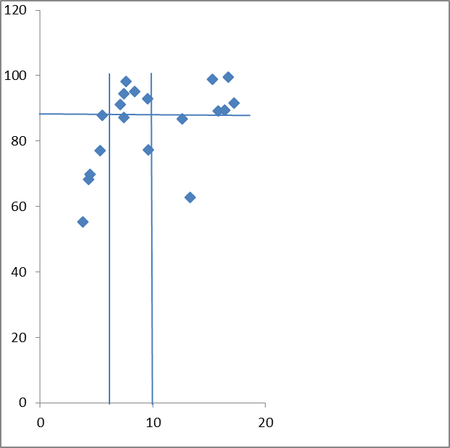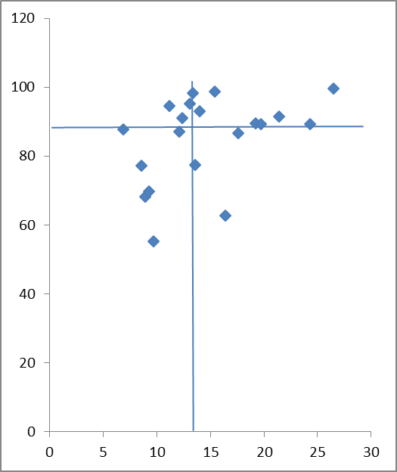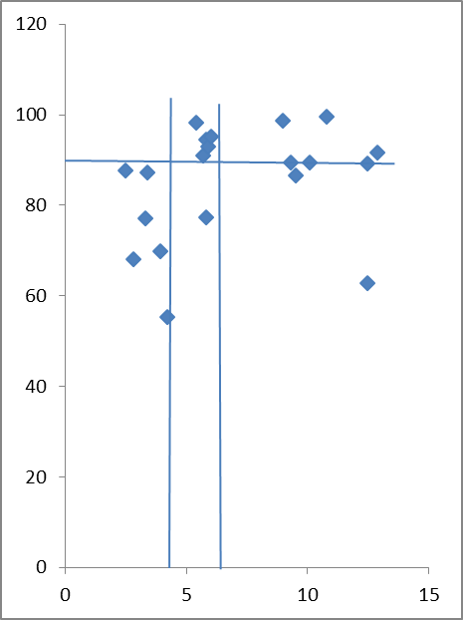

Figure 1: The relationships between available P determined by the extractants and relative maize grain yield

Quantitative evaluation of crop response and soil tests (Nelson and Anderson, 1977) was used to analyze the data and determine critical levels of available P with which to identify soils where crops will respond to P application and those that will not. The critical levels determined by the graphical and analysis of variance methods are 14.0, 8.5 and 5.5 mg kg-1; 15.4, 8.4 and 6.0 of available P (mg kg-1) for Mehlich 3, Bray’s P-1 and modified 0.5M NaHCO3 extractants respectively (Table 3). Thus, it was necessary to compare the expected and observed responses based on the critical levels established for the extractants which separate relative yield values below 88% as high (Yes) and above as low/none (No) responses (Table 4). This relative yield is lower than 95% suggested as the value generally accepted for a nutrient not to be considered as limiting (Mollarino, 2003). The misses between expected and observed responses based on the graphical method’s critical levels belong to soils with low available P that showed little or no response and those with high available P that responded to P fertilizer application

.Table 3: Critical levels and soil test calibration for maize in soils of the derived and Southern Guinea Savannah zones of South-west Nigeria

Critical levels Bray’s P-1 Mehlich III 0.5M NaHCO3

Graphical method 8.5 14.0 5.5

ANOV method 8.4 15.4 9.0

Low

Medium 0-5.5 0-13.4 0-5.8

High 5.6-8.4 13.5-15.4 5.9-9.0

Critical levels >8.4 >15.4 >9.0

**Graphical method**

<1.5 g kg-1 organic matter 7.4 14.0 5.5

>1.5 g kg-1 organic matter 7.6 13.0 5.4

**ANOV method**

<1.5 g kg-1 organic matter 7.4 15.4 9.0

>1.5 g kg-1 organic matter 7.6 13.4 6.0

Table 4: Predicted and observed responses of maize to P application in soils from the derived savannah zone of South-west Nigeria

|  |  |  |  |  |  |  |  |  |  |  |  |  |  |  |
| --- | --- | --- | --- | --- | --- | --- | --- | --- | --- | --- | --- | --- | --- | --- |
| Location | B | RY | ER | OR | Location | M | RY | ER | OR | Location | N | RY | ER | OR |
| Igboora  Ashileke  Ipapo  Iganna  Ogbomoso  Sepeteri  Eruwa I  Ilero I  Oko  Ilora I  Ikare  Ipele  Ilero II  Ejigbo  Kishi  Ilora II  Idoani  Fashola  Eruwa II  Omuo | 3.8  4.3  4.4  5.3  5.5  7.1  7.4  7.4  7.6  8.4  9.5  9.6  12.6  13.3  15.3  15.8  16.4  16.4  16.7  17.2 | 55.2  68.2  69.8  77.2  87.8  91.1  94.5  87.2  98.2  95.2  93.0  77.4  86.7  62.8  98.8  89.2  89.5  89.4  99.5  91.7 | Yes  Yes  Yes  Yes  Yes  Yes  Yes  Yes  Yes  Yes  No  No  No  No  No  No  No  No  No  No | Yes  Yes  Yes  Yes  Yes  No  No  Yes  No  No  No  Yes  Yes  Yes  No  No  No  No  No  No | Ogbomoso  Iganna  Ashileke  Ipapo  Igboora  Eruwa I  Ilero I  Shepeteri  Ilora I  Oko  Ipele  Ikare  Kishi  Ejigbo  Ilero II  Idoani  Ilora II  Omuo  Fashola  Eruwa II | 6.9  8.6  8.9  9.3  9.7  11.2  12.1  12.4  13.1  13.4  13.6  14.0  15.4  16.4  17.6  19.2  19.7  21.4  24.3  26.5 | 87.8  77.2  68.2  69.8  55.3  94.5  87.2  91.1  95.2  98.2  77.4  93.0  98.8  62.8  86.7  89.5  89.2  91.7  89.4  99.5 | Yes  Yes  Yes  Yes  Yes  Yes  Yes  Yes  Yes  Yes  Yes  Yes  No  No  No  No  No  No  No  No | Yes  Yes  Yes  Yes  Yes  No  Yes  No  No  No  Yes  No  No  Yes  Yes  No  No  No  No  No | Ogbomoso  Ashileke  Iganna  Ilero I  Ipapo  Igboora  Oko  Shepeteri  Eruwa I  Ipele  Ikare  Ilora I  Kishi  Idoani  Ilero II  Fashola  Eruwa II  Ejigbo  Ilora II  Omuo | 2.5  2.8  3.3  3.4  3.9  4.2  5.4  5.7  5.8  5.8  5.9  6.0  9.0  9.3  9.5  10.1  10.8  12.5  12.5  12.9 | 87.8  68.2  77.2  87.2  69.8  55.3  98.2  91.1  94.5  77.4  93.0  95.2  98.8  89.5  86.7  89.4  99.5  62.8  89.2  91.7 | Yes  Yes  Yes  Yes  Yes  Yes  Yes  No  No  No  No  No  No  No  No  No  No  No  No  No | Yes  Yes  Yes  Yes  Yes  Yes  No  No  No  Yes  No  No  No  No  Yes  No  No  Yes  No  No |

B= Bray’s P-1 extractant; M= Mehlich III; N= Modified 0.5M NaHCO3 (pH=8.5), RY= Relative Yield (%), ER= Expected Response; OR= Observed Response

The values are 6 (30%), 7 (35%) and 4 (20%) for Mehlich 3, Bray’s P-1 and 0.5M NaHCO3 respectively, suggesting that the methods extracted amounts that did not represent the index of P availability in some locations and the predictions of P fertilizer needs of maize would be inaccurate. In order to make the soil tests a valuable component of the technology that emphasizes fertilizer best management practices, some things need to be done. The separation of soils at the series level would have ensured a clearer identification of responsive and non-responsive sites needed to establish the critical levels and without misses between predicted and observed responses of sugar beet to P application (Varvel et al., 1981). Soil survey and classification activities in Nigeria are at reconnaissance level of 1:250,000 field scale while the ensuing reports and maps produced at 1: 650,000 (FDALR, 1990) are only suitable for regional planning and location of development areas (Ojanuga, 2012).Thus, similar separation of soils used for this study at the series level is impossible now and so consideration was given to intrinsic properties which influence P availability in the soils. The correlations between available P extractants had improved by excluding the high-end P values or by using the pH values to segregate the soils into groups (Mylavarapu *et al*., 2002). The pH range is narrow in the soils used for this study while organic matter rather than clay content exerted greater influence on P availability in soils of the savannah zone in south-western Nigeria and so the soils were separated based on the suggested critical level of 1.5% organic matter content (Ayodele 1986).The scatter diagrams of the relationships between available P and relative yield drawn for each class (Fig 2) gave critical levels of 14.0, 7.4 and 5.6 mg kg-1 for Mehlich 3, Bray’s P-1 and modified 0.5M NaHCO3 respectively in the soils with <15 g kg-1 organic matter content based on the graphical method.

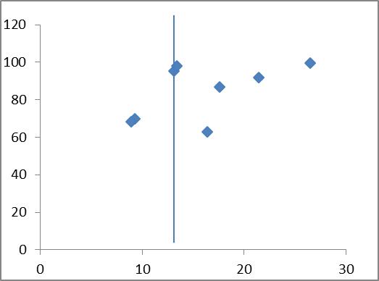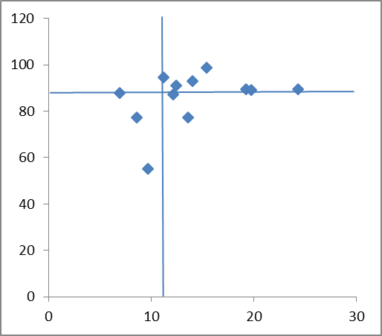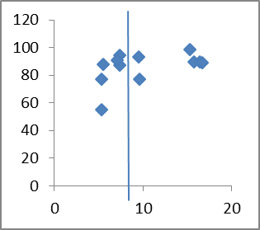

The misses were two (2) for Mehlich 3 and Bray’s P-1 and one (1) for 0.5M NaHCO3. Mehlich 3, Bray’s P-1 and 0.5M NaHCO3 had critical levels of 13.0, 7.6 and 5.4 mg kg-1 respectively in the soils with >15 g kg-1 organic matter and the number of misses between expected and observed responses was one (1) for each extractant (Fig. 3).

Fig. 2: The relationships between available P and relative yield in soils containing <15 g kg-1 organic matter

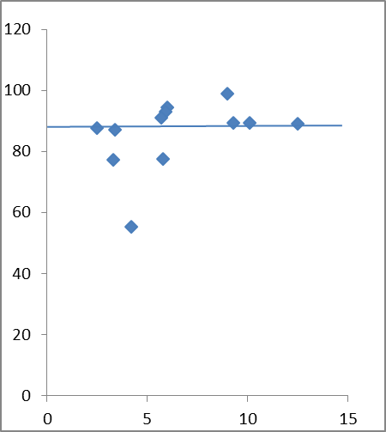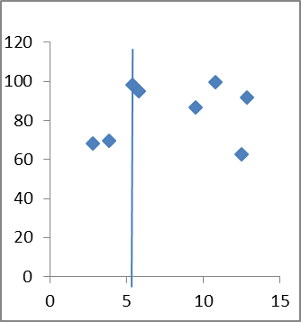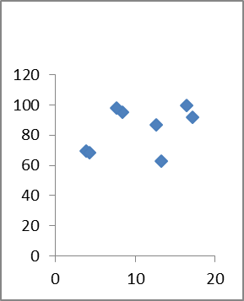

Fig. 3: The relationship between available P and relative yield of maize in soils with >15 g kg-1 organic matter

Figure 4:

The response categories were more clearly separated and the precision of response prediction increased by 57.1 percent for Bray’s P-1 and 50% for Mehlich 3 and 0.5M NaHCO3 while the critical levels were similar for the two soil classes. This separation of soils based on organic matter content, which is determined in routine laboratory tests, constitutes a refinement that increased the precision with which the extractants predicted the response of maize to P fertilizer application and so indicates improvement in the correlation of available P in the soils. The accurate prediction of the P fertilizer requirements in soils with high possibility of responses would require that the soil tests be calibrated. This will ensure the recommendation of specific amounts of P fertilizer that correspond to the P soil test value or index of availability for each soil. The response curve was partitioned into groups that correspond to low, medium and high soil-crop categories or indices of soil available P (Table 3). Based on the soil-crop categories, two, three and five sites belong to the low, medium and high index of P availability respectively. The plots of relative yields of maize for P treatments in each site against the P rates (Fig. 4) were described with quadratic equations. The rates of P required by maize to attain 88 and 95% of the maximum yield in each sites belonging to low, medium and high available P classes were determined (Table 5).

Table 5: P fertilizer rates calculated from quadratic equations for the soil-crop categories

Recommended P fertilizer rate (kg ha-1)

Locations Available P Soil Index 88% 95% of Maximum Yield

Ipapo 4.4 Low 26.0 40.0

Ogbomoso 5.5 Low 15.0 27.0

Eruwa 7.4 Medium 29.0 48.0

Ilero 7.4 Medium 11.0 20.0

Ilora 8.4 Medium 0.0 25.0

Ikare 9.5 High 30.0 48.0

Ejigbo 13.3 High 0.0 0.0

Owani 15.8 High 0.0 36.0

Fashola 16.4 High 7.0 18.0

Omuo 17.2 High 0.0 0.0

**Conclusion**

The surface layers of soils in 20 farmers’ plots used for P response study contained varied P fractions which correlated significantly with the available P determined by three extractants. The order of performance in extractable P was Mehlich 3 > Bray’s P-1 > modified 0.5M NaHCO3. Correlations with relative yield of maize were low indicating <50% response prediction but it was possible to determine critical levels with the graphical method as 8.5, 14.0 and 5.5 mg kg-1 for Bray’s P-1, Mehlich 3 and modified 0.5M NaHCO3 respectively. The number of misses between expected and observed responses reduced when soils were separated into two classes based on 1.5% soil organic matter content. The response curves were used to separate available P into low, medium and high classes. P fertilizer application in these classes showed varied responses which were used to determine the P rate needed for the respective available P to attain optimum yield.

**References**

Adepetu, J.A. and Corey, R.B. 1976. Organic phosphorus as a predictor of plant available Pin soils of southern Nigeria. *Soil Science* 122: 159-164.

Anon, 2006. *Nigeria Fertilizer Strategy Report*; presented at African fertilizer Summit, International Conference Centre, Abuja, 9-13th June, 2006. 47pp.

Ayodele, O. and Agboola, A. 1985. Calibration of available P in soils from derived savannah zone of Western Nigeria. *Fertilizer Research* 6: 121-129.

Ayodele, O.J. 1986. Phosphorus availability in savannah soils of Western Nigeria. *Tropical Agriculture (Trinidad)* 63: 297-300.

Bamalli, U.S., Moumouni, A and Chaanda, M.S. 2011. A review of Nigerian metallic minerals for technological development. *Natural Resources* 2: 87-91.

Brady, N.C and Weil, R.R. 2004. *Elements of the Nature and Properties of Soils*. 2nd Edition, Pearson Education Inc., Prentice Hall, Upper Saddle River, New Jersey. 606 pp.

Chang, S.C. and Jackson, M.L. 1957. Fractionation of soil phosphorus. *Soil Science* 84: 133-144.

FDALR, 1990. *The Reconnaissance Soil Survey of Nigeria (1: 650,000). Soils Report Volume I-IV.* Federal Department of Agricultural Land Resources (FDALR), Federal Ministry of Agriculture and Natural Resources, Abuja.

Heckman, J.R. 2006. *Soil Fertility Test Interpretation: Phosphorus, Potassium, Magnesium and Calcium*. Rutgers Cooperative Extension Fact Sheet FS 719. 4pp.

Hunter, A.H. 1972. Soil Analytical Procedure using the Modified NaHCO3 Extracting Solution. International Soil Fertility Evaluation Improvement Project, North Carolina State University, Raleigh, N.C.

Jones, J.B. Jr. 2002. *Laboratory Guide for Conducting Soil Tests and Plant Analysis*. CRC Press, Boca Raton. 363 pp.

Jones, M.J. and Wild, A. 1975. *Soils of the West African Savanna. The Maintenance and Improvement of their Fertility*. Technical Communicate. No 55, Commonwealth Bureau of Soils, Harpenden. 246pp.

Kang, B.T. and Osiname, O.A. 1979. Phosphorus response of maize grown on Alfisols of southern Nigeria. *Agronomy Journal* 71: 873-877.

Masjkur, M. 2009. Correlation between soil test phosphorus of kaolinitic and smectitic soils with phosphorus uptake of lowland rice. *Journal Tanah Trop.* 14: 205-209

Mehlich, A. 1984. Mehlich 3 extractant: a modification of Mehlich 2 extractant. *Communications in Soil Science and Plant Analysis* 15: 1409-1416.

Mollarino, A.P. 2003. Field calibration for corn of the Mehlich 3 soil phosphorus test with colorimetric and inductively coupled plasma emission spectroscopy determination methods. *Soil Science Society of America Journal* 68: 1928-1934.

Murdoch, G., Ojo-Atere, J., Colborne, G., Olomu, E.I. and Odugbesan, E.M. 1976. *Soils of the Western State Savannah in Nigeria*. Land Resource Study 23, Land Resources Division, Ministry of Overseas Development, England.

Mylavarapu, R.S., Sanchez, J.F., Nguyen, J.H. and Bartos, J.M. 2002. Evaluation of Mehlich-1 and Mehlich-3 extraction procedures for plant nutrients in acid mineral soils of Florida. *Communications in Soil Science and Plant Analysis* 33 (5&6): 807-820

Nelson, L.A. and Anderson, R.L. 1977. Partitioning of soil test-crop response probability. In: Peck, T.R., Cope, J.T. Jr. and Whitney, D.A. (eds) *Soil Testing: Correlating and Interpreting Analytical Results*. Agronomy Society of America Special Publication 29: 19-38.

Nzewi, G.I. 1974. *Methods for Routine Analysis in Nigeria.* A Publication of Federal Department of Agriculture, Federal Ministry of Agriculture and Natural Resources, Lagos. 17pp.

Ojanuga, A.G. 2012. Soil survey and land use planning: An inevitable tool for agricultural land resources mobilization for sustainable agribusiness investment. Paper presented at Stakeholders Meeting on National Soil Survey Programme held at ARCN Conference Hall, Mabushi, Abuja; 17th October 2012. 14pp.

Sims, J.T., Hodges, S. and Davis, J. 1998. Soil testing for phosphorus: current status and uses in nutrient management programs. In: Sims, J.T. (ed). Soil Testing for Phosphorus: Environmental Uses and Implications. Southern Cooperative Series Bulletin No 389: 10-14.

Steel, R.D.G., Torrie, J.H. and Dickey, D.A. 1997. *Principles and Procedures of Statistics: A Biometrical Approach*. 3rd Edition. McGraw Hill, New York. 665pp.

Tisdale, S.L., Nelson, W.L., Beaton, J.D. and Havlin, J.L. 1993. *Soil Fertility and Fertilizers.* 5th Edition, Macmillan, New York.

Udo, E.J. and Ogunwale, J.A. 1977. Phosphorus fractions in selected Nigerian soils. *Soil Science Society of America Proceedings* 41: 1141-1146.

Udo, E.J. and Ogunwale, J.A. 1986*. Laboratory Manual for the Analysis of Soil, Plant and Water Samples.* Department of Agronomy, University of Ibadan, Nigeria. 2nd Edition, Imperial Binding Service. 147 pp.

Uzu, F.O. Juo, A.S.R. and Fayemi, A.A. 1975. Forms of phosphorus in some important agricultural soils of Nigeria. *Soil Science* 120: 212-218.

Varvel, G.E., Anderson, F.N, and Peterson, G.A. 1981. Soil test correlation problems with two phosphorus methods on similar soils. *Agronomy Journal* 73: 516-520.

Watson, M. and Mullen, R. 2007. *Understanding Soil Tests for Plant-Available Phosphorus*. The Ohio State University Extension Fact Sheet 3373. 4pp.

Westerman, R.L. 1990. *Soil Testing and Plant Analysis.* 3rd Edition. Soil Science Society of America, Madison.